**1. Install CLI – Introduction**

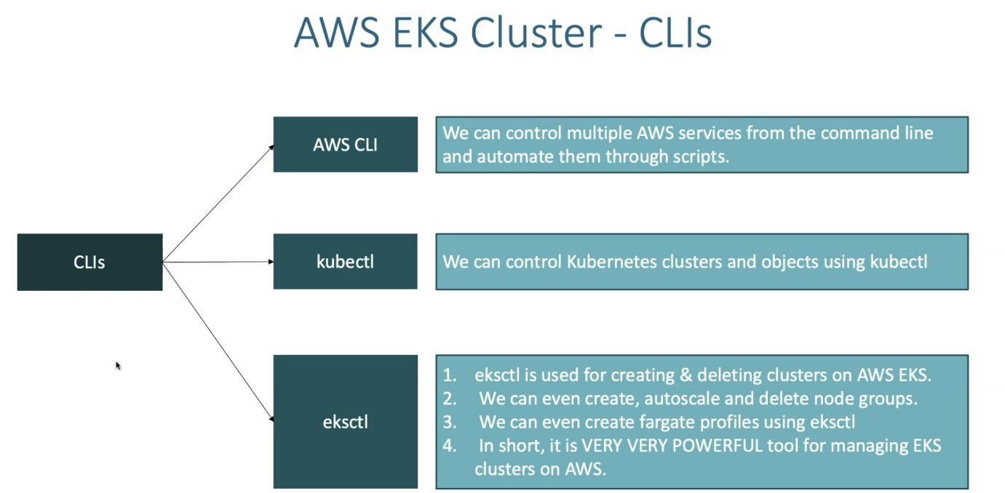

--- to manage our application workloads on kubernetes cluster, we need to install three types of CLI command line interfaces. the three types are CLI’s are **AWS CLI**, **KUBECTL**, **eksctl**. So, this is a generic definition of what database yearly.

--- **note** - once we configure the AWS CLI and then provider security credentials on our local desktop with AWS CLI. using kubectl and eksctl we will able to manage our cluster and also our applications on kubernetes cluster. For this purpose, we need to install AWS cli as base tool.

**Documents on github**

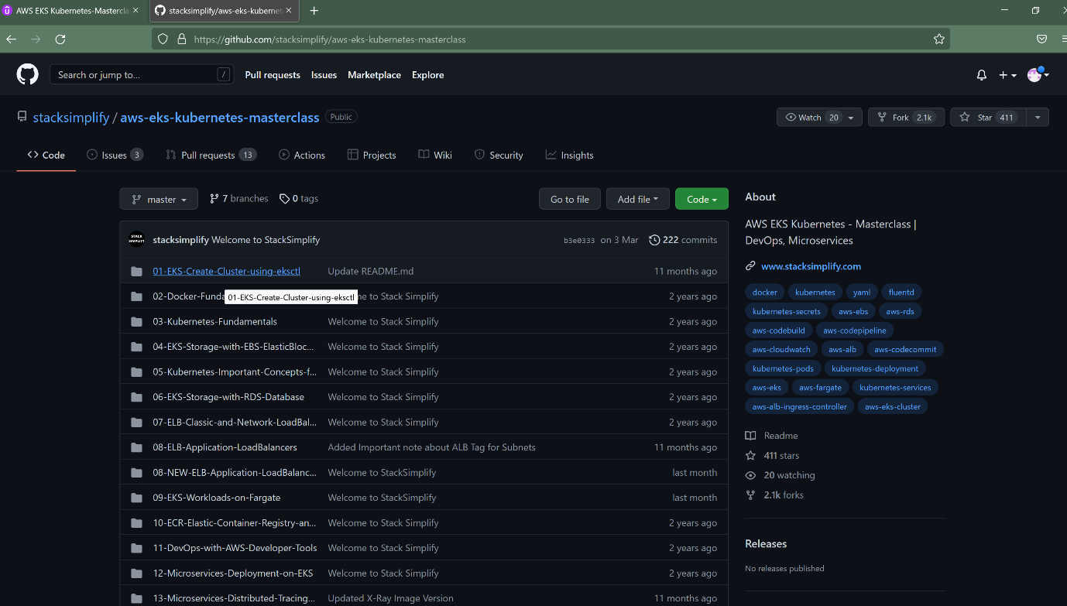

--- **https://github.com/stacksimplify**

--- after clicking on the above link, click on the **aws-eks-kubernetes-masterclass** repository then click on the o1 folder.

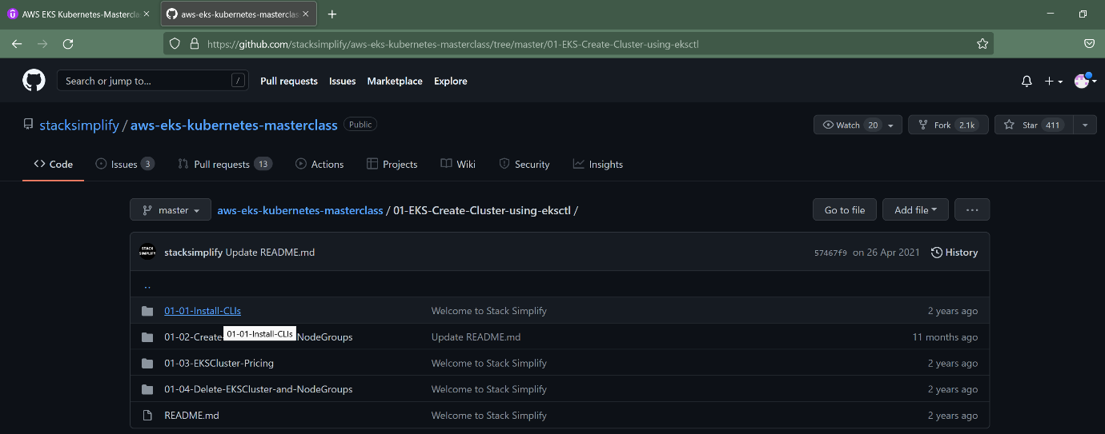

--- click on the 01-01-install-clis folder to see the complete document.

**Installation process and document**

Install AWS, kubectl & eksctl CLI's

Step-00: **Introduction**

* Install AWS CLI
* Install kubectl CLI
* Install eksctl CLI

Step-01: **Install AWS CLI**

* Reference-1: <https://docs.aws.amazon.com/cli/latest/userguide/cli-chap-install.html>
* Reference-2: <https://docs.aws.amazon.com/cli/latest/userguide/install-cliv2.html>

Step-01-01: **MAC - Install and configure AWS CLI**

* Download the binary and install via command line using below two commands.

**# Download Binary**

--- **curl "https://awscli.amazonaws.com/AWSCLIV2.pkg" -o "AWSCLIV2.pkg"**

**# Install the binary**

--- **sudo installer -pkg ./AWSCLIV2.pkg -target /**

* **Verify the installation**

--- **aws --version**

aws-cli/2.0.7 Python/3.7.4 Darwin/19.4.0 botocore/2.0.0dev11

which aws

* Reference: <https://docs.aws.amazon.com/cli/latest/userguide/install-cliv2-mac.html>

Step-01-02: Windows 10 - **Install and configure AWS CLI**

* The AWS CLI version 2 is supported on Windows XP or later.
* The AWS CLI version 2 supports only 64-bit versions of Windows.
* Download Binary: <https://awscli.amazonaws.com/AWSCLIV2.msi>
* Install the downloaded binary (standard windows install)

--- **aws --version**

aws-cli/2.0.8 Python/3.7.5 Windows/10 botocore/2.0.0dev12

* Reference: <https://docs.aws.amazon.com/cli/latest/userguide/install-cliv2-windows.html>

Step-01-03: Configure AWS Command Line using Security Credentials

* Go to AWS Management Console --> Services --> IAM
* Select the IAM User: kalyan
* Important Note: Use only IAM user to generate Security Credentials. Never ever use Root User. (Highly not recommended)
* Click on Security credentials tab
* Click on Create access key
* Copy Access ID and Secret access key
* Go to command line and provide the required details

aws configure

AWS Access Key ID [None]: ABCDEFGHIAZBERTUCNGG (Replace your creds when prompted)

AWS Secret Access Key [None]: uMe7fumK1IdDB094q2sGFhM5Bqt3HQRw3IHZzBDTm (Replace your creds when prompted)

Default region name [None]: us-east-1

Default output format [None]: json

* Test if AWS CLI is working after configuring the above

aws ec2 describe-vpcs

Step-02: **Install kubectl CLI**

* IMPORTANT NOTE: Kubectl binaries for EKS please prefer to use from Amazon (Amazon EKS-vended kubectl binary)
* This will help us to get the exact Kubectl client version based on our EKS Cluster version. You can use the below documentation link to download the binary.
* Reference: <https://docs.aws.amazon.com/eks/latest/userguide/install-kubectl.html>

Step-02-01: **MAC - Install and configure kubectl**

* Kubectl version we are using here is 1.16.8 (It may vary based on Cluster version you are planning use in AWS EKS)

**# Download the Package**

--- **mkdir kubectlbinary**

--- **cd kubectlbinary**

--- **curl -o kubectl https://amazon-eks.s3.us-west-2.amazonaws.com/1.16.8/2020-04-16/bin/darwin/amd64/kubectl**

**# Provide execute permissions**

--- **chmod +x ./kubectl**

**# Set the Path by copying to user Home Directory**

--- **mkdir -p $HOME/bin && cp ./kubectl $HOME/bin/kubectl && export PATH=$PATH:$HOME/bin**

**echo 'export PATH=$PATH:$HOME/bin' >> ~/.bash_profile**

**# Verify the kubectl version**

--- **kubectl version --short --client**

Output: Client Version: v1.16.8-eks-e16311

Step-02-02: **Windows 10 - Install and configure kubectl**

* Install kubectl on Windows 10

--- **mkdir kubectlbinary**

--- **cd kubectlbinary**

--- **curl -o kubectl.exe https://amazon-eks.s3.us-west-2.amazonaws.com/1.16.8/2020-04-16/bin/windows/amd64/kubectl.exe**

* Update the system Path environment variable

C:\Users\KALYAN\Documents\kubectlbinary

* Verify the kubectl client version

kubectl version --short --client

kubectl version --client

Step-03: **Install eksctl CLI**

Step-03-01: **eksctl on Mac**

**# Install Homebrew on MacOs**

--- **/bin/bash -c "$(curl -fsSL https://raw.githubusercontent.com/Homebrew/install/master/install.sh)"**

**# Install the Weaveworks Homebrew tap.**

--- **brew tap weaveworks/tap**

**# Install the Weaveworks Homebrew tap**.

--- **brew install weaveworks/tap/eksctl**

**# Verify eksctl version**

--- **eksctl version**

Step-03-02: eksctl on windows or linux

* For windows and linux OS, you can refer below documentation link.
* Reference: <https://docs.aws.amazon.com/eks/latest/userguide/eksctl.html#installing-eksctl>

References:

* <https://docs.aws.amazon.com/eks/latest/userguide/getting-started-eksctl.html>